PocketSmart AI
Smart Budget & Recommendation Assistant
Project Description:
PocketSmart AI is a Generative AI-powered budgeting assistant that creates personalized, budget-aware recommendations across Home Interior, Party Budget, and Jewelry planning. The application combines FastAPI, Jinja2 templates, JWT authentication, JSON-file persistence, and a Gemini-powered recommendation layer. The supplied README states that the system can operate without an external database and can fall back to locally computed estimates when Gemini is unavailable.
The Jewelry Planner additionally supports an optional outfit image. The uploaded image is saved under static/uploads and its bytes are passed to the recommendation function for color-aware suggestions. The overall objective is to convert a user’s budget and preferences into practical, itemized planning recommendations.
Scenarios
Scenario 1: A user wants to furnish several rooms within a fixed budget. The Home Interior Planner accepts the budget, room types, requested items, and style preference, then produces itemized recommendations.
Scenario 2: A user is organizing an event such as a birthday, wedding, or corporate gathering. The Party Budget Planner uses budget, guest count, event type, venue preference, and location to generate a structured plan.
Scenario 3: A user needs jewelry for a particular occasion and outfit. The Jewelry Planner accepts budget, occasion, style preference, and an optional outfit image to support context-aware recommendations.

Technical Architecture:
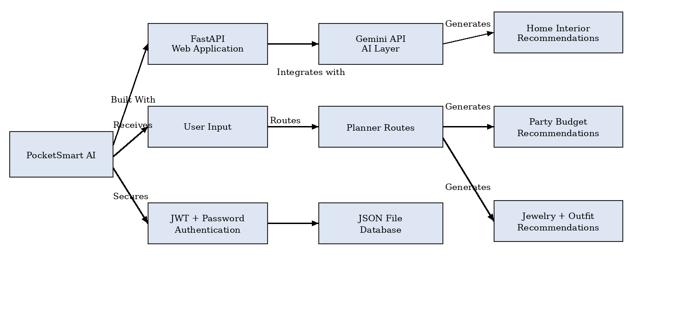
Figure 1: PocketSmart AI technical architecture in the same box-and-arrow visual style as the sample document.
Description
The application is organized around a FastAPI core that initializes configuration, middleware, static assets, templates, authentication routes, and planner routes. Planner routes collect user inputs, call the appropriate Gemini recommendation function, store the generated result in user history, and render the recommendation page. The README describes a separate Gemini utility layer for prompt construction, response parsing, and deterministic local fallback.
The architecture also separates authentication from planning and storage. User access is enforced by current-user dependencies, while the JSON-file database records user and recommendation history. Jewelry adds an optional multimodal path for outfit images.

Pre-requisites:
• Python 3.10+ as specified by the supplied README.
• FastAPI 0.111.0, Uvicorn 0.30.1, Jinja2 3.1.4 and python-multipart 0.0.9.
• python-dotenv, python-jose, passlib, bcrypt for configuration and authentication.
• google-generativeai 0.7.2 and Pillow 10.4.0 for AI and image handling.
• VS Code or another Python IDE and a modern browser.
Project Structure
pocketsmart-ai/
├── main.py
├── requirements.txt
├── .env.example
├── app/
│ ├── auth.py
│ ├── database.py
│ ├── gemini_utils.py
│ ├── models.py
│ └── routes/
│ ├── auth_routes.py
│ └── planner_routes.py
├── templates/
├── static/
│ ├── css/style.css
│ ├── js/main.js
│ └── uploads/
└── data/
The structure is taken from README.md. Modules referenced there but not uploaded in this request are described only where the README explicitly documents their role.

Project Workflow:
Milestone 1: Model Selection and Architecture
• Configure Gemini and runtime environment.
• Define application architecture and security boundary.
• Prepare development environment and dependencies.
Milestone 2: Core Functionalities Development
• Implement Home, Party, and Jewelry planners.
• Connect generation routes to AI and history storage.
Milestone 3: main.py Development
• Create FastAPI app, middleware, static/template handling, routers, public pages, health and startup logic.
Milestone 4: Frontend Development
• Develop Jinja2 page flow and responsive styling.
• Present itemized recommendations and history.
Milestone 5: Deployment
• Install dependencies, configure .env, run Uvicorn and verify /health and /docs.
Milestone 6: Conclusion
• Validate end-to-end flow and identify production enhancements.

Milestone 1: Model Selection and Architecture
The foundation of PocketSmart AI is a configurable Gemini-backed FastAPI service. The current supplied .env sets GEMINI_MODEL=gemini-3.5-flash. The README still mentions Gemini 1.5 Flash Pro, so the documentation treats the environment configuration as the active setting and flags the README reference as older documentation.
Activity 1.1: Configure the Gemini API and Runtime Environment
main.py loads environment variables before importing modules that read GEMINI_API_KEY. This ordering makes the runtime configuration available to the Gemini utility layer. SECRET_KEY and ACCESS_TOKEN_EXPIRE_MINUTES are also supplied through .env for authentication.
Security Handling
Credentials are kept outside Python source. The real .env supplied with the project is not reproduced; the documentation uses a redacted screenshot on the next page.

Source Code Screenshot: main.py
The following VS Code-style image is generated directly from the uploaded main.py file and shows the application entry point, middleware, routes, and startup logic.
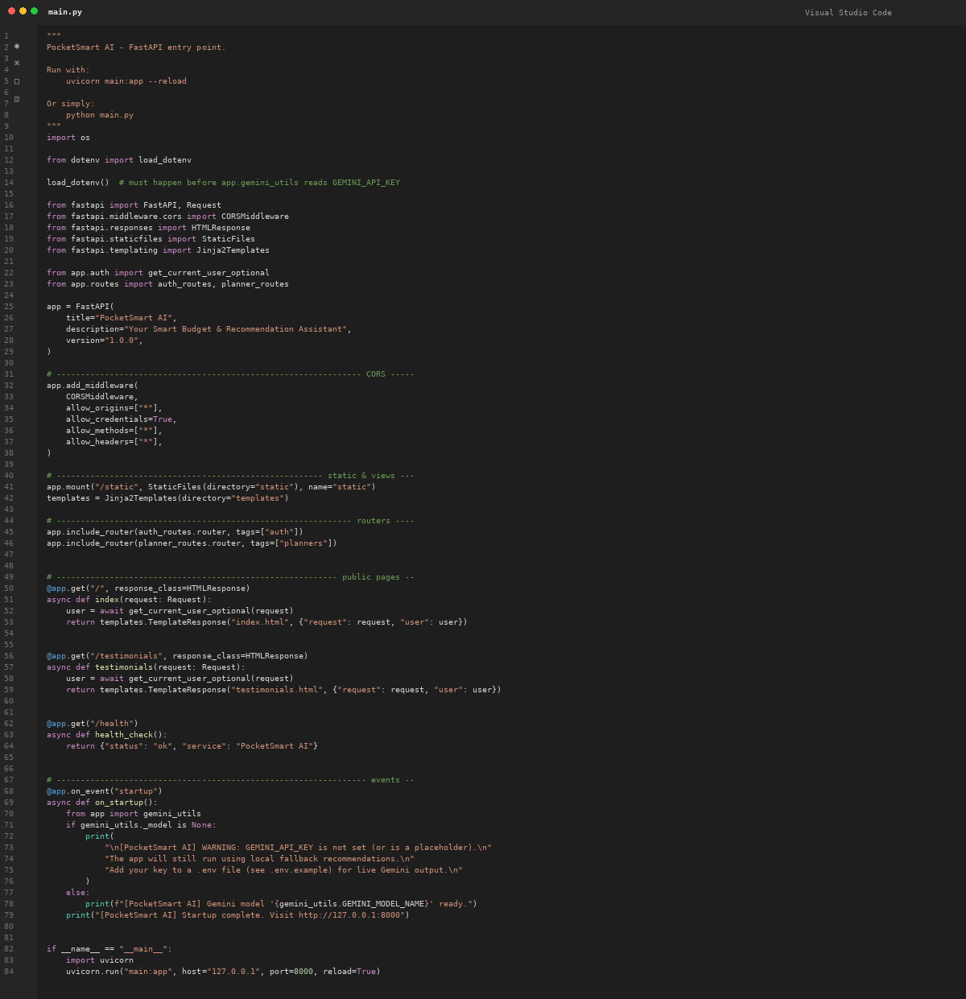
Figure 2: VS Code-style screenshot generated from the supplied main.py source file.

Activity 1.1: Environment Variables
The supplied .env contains GEMINI_API_KEY, SECRET_KEY, GEMINI_MODEL, and ACCESS_TOKEN_EXPIRE_MINUTES. Sensitive values are intentionally redacted below. The current token lifetime setting is 1200 minutes.
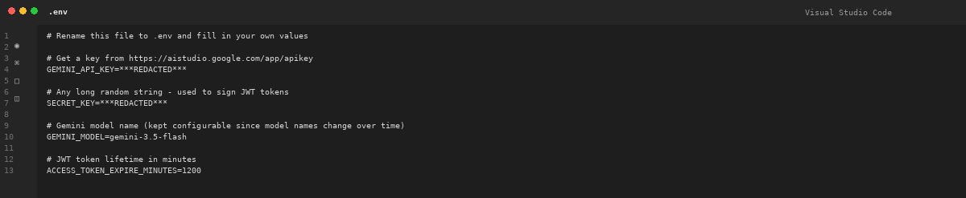
Figure 3: VS Code-style .env screenshot with secret values redacted.

Activity 1.2: Research and Select the Appropriate Generative AI Model
The AI model is configurable through GEMINI_MODEL rather than embedded in the FastAPI entry point. The dependency set pins google-generativeai==0.7.2. The project therefore separates AI model configuration from application routing.
Dependency | Purpose
fastapi==0.111.0 | Web framework
uvicorn[standard]==0.30.1 | ASGI server
jinja2==3.1.4 | Server-side templates
python-multipart==0.0.9 | Form/file handling
python-dotenv==1.0.1 | Environment configuration
python-jose / passlib / bcrypt | JWT and password security
google-generativeai==0.7.2 | Gemini integration
pillow==10.4.0 | Image processing
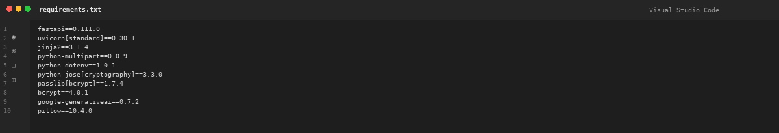
Figure 4: VS Code-style requirements.txt screenshot generated from the supplied file.

Activity 1.3: Define the Architecture of the Application
The application separates initialization, authentication, planner routing, AI generation, storage, and presentation. The main router includes auth_routes and planner_routes. The planner router depends on get_current_active_user, calls gemini_utils, records history, and renders recommendations.html.
Key Responsibilities
• FastAPI: request routing, middleware, templates and service lifecycle.
• Authentication: JWT issuance/verification and current-user dependencies as documented in README.md.
• Planner routes: dashboard, three planners, generation endpoints, recommendation details, and history.
• Gemini layer: prompt construction, JSON parsing, and local fallback as documented in README.md.
• Storage: JSON files for users and recommendation history.

Activity 1.4: Set Up the Development Environment
1. Open the project in VS Code.
2. Create a virtual environment: python -m venv venv.
3. Activate it on Windows: venv\Scripts\activate.
4. Install dependencies: pip install -r requirements.txt.
5. Create/configure .env with the required runtime variables.
6. Run uvicorn main:app --reload or python main.py.
7. Open http://127.0.0.1:8000 and verify /health and /docs.
Startup Behavior
At startup, main.py checks whether the Gemini utility has initialized a model. If the key is missing or a placeholder, the application prints a warning and states that local fallback recommendations will be used. Otherwise, it reports the configured Gemini model as ready.

Milestone 2: Core Functionalities Development
PocketSmart AI provides three domain-specific planners. Each planner uses a typed input concept, a protected route, a Gemini recommendation function, history storage, and a shared recommendations template.
Activity 2.1: Develop Core Planning Features
Planner | Inputs | Purpose
Home Interior | Budget; room types; items; style | Furniture, lighting and decor planning
Party Budget | Budget; guest count; event type; venue; location | Catering, venue, decoration and entertainment planning
Jewelry Budget | Budget; occasion; style; optional image | Jewelry recommendations with optional outfit context
The supplied models.py defines Pydantic schemas for these planning concepts, while planner_routes.py accepts the corresponding form parameters directly in its route handlers.

Source Code Screenshot: models.py
The following screenshot is generated from the uploaded models.py file. It shows the authentication models and planner input schemas used by the application.
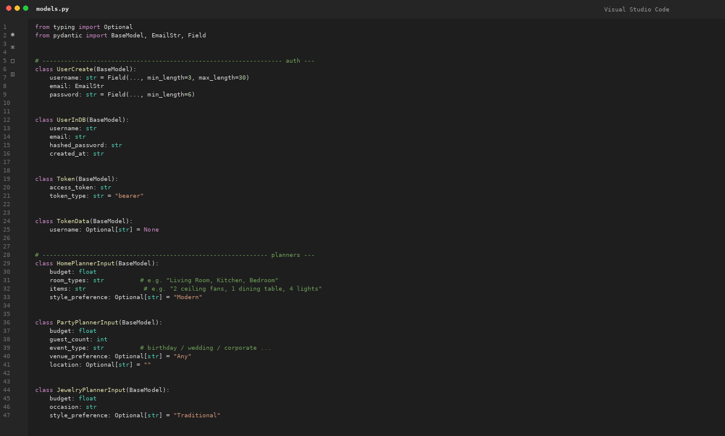
Figure 5: VS Code-style screenshot generated from the supplied models.py source file.

Activity 2.2: Implement the FastAPI Backend
planner_routes.py defines protected routes for the dashboard and all three planners. A generation route receives typed form parameters, calls the relevant Gemini utility function, writes a history entry for the current user, and renders recommendations.html with the input and result.
result = gemini_utils.get_home_recommendations(
budget, room_types, items, style_preference
)
database.add_history_entry(
current_user.username, "Home", input_data, result
)
The same pattern is applied to Party and Jewelry. This common structure makes the application modular while allowing each planner to retain domain-specific inputs.

Source Code Screenshot: planner_routes.py — Part 1
This screenshot shows the dashboard, Home Planner, and Party Planner portions of the uploaded planner_routes.py file.
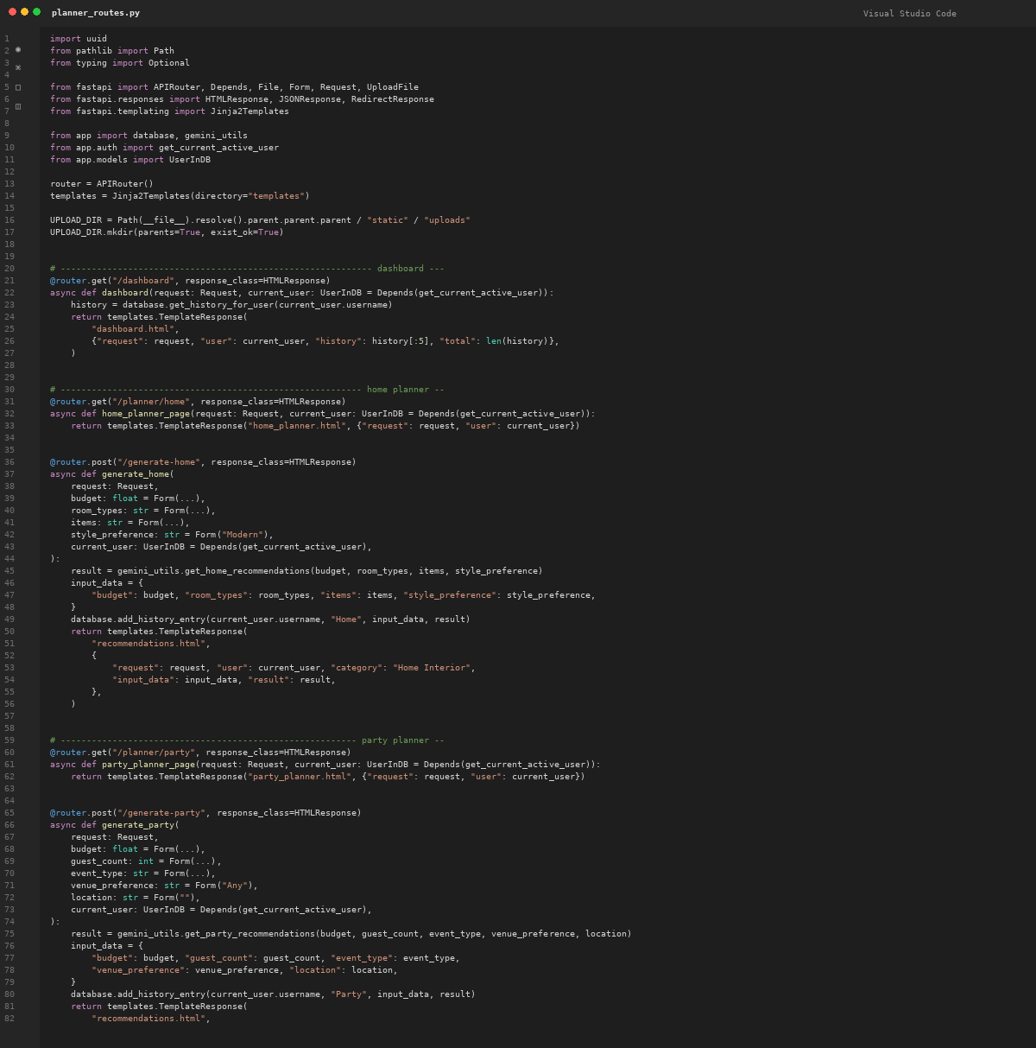
Figure 6: VS Code-style screenshot generated from planner_routes.py, lines 1–82.

Source Code Screenshot: planner_routes.py — Part 2
This screenshot shows the Jewelry Planner, recommendation detail, and history routes from the uploaded source file.
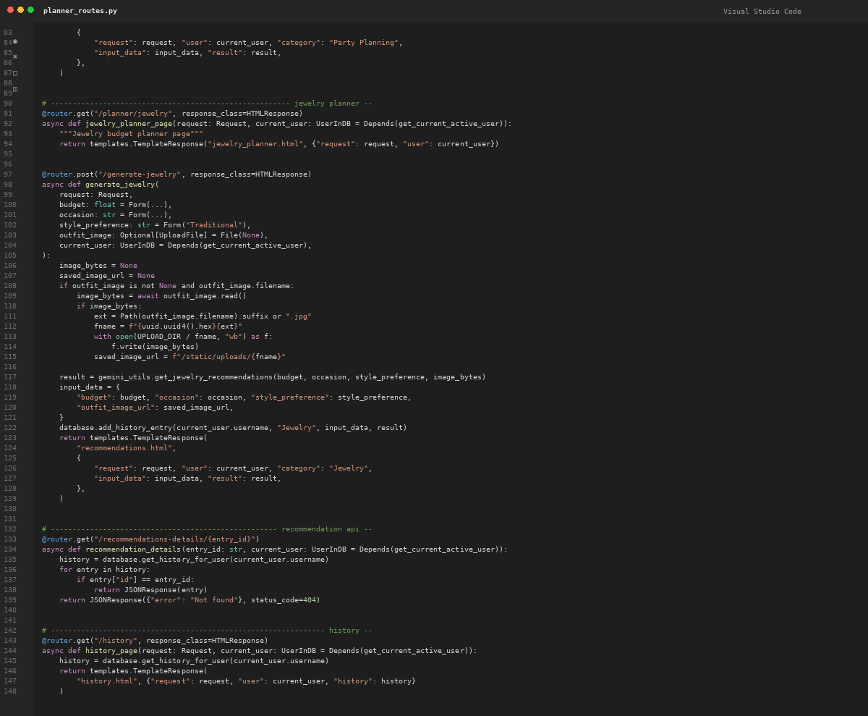
Figure 7: VS Code-style screenshot generated from planner_routes.py, lines 83–149.

Milestone 3: main.py Development
main.py is the application backbone. It creates the FastAPI instance, configures CORS, mounts static files, initializes Jinja2 templates, includes authentication and planner routers, exposes public pages, provides a health endpoint, and performs startup diagnostics.
Activity 3.1: Main Application Logic
• Root / renders index.html and passes the optional current user.
• /testimonials renders testimonials.html.
• /health returns a JSON status response.
• Startup checks Gemini readiness and announces fallback behavior when needed.
• The __main__ block launches Uvicorn on 127.0.0.1:8000 for development.
CORS Consideration
The current implementation allows all origins, methods, and headers. This is convenient during development but should be narrowed to trusted origins in a production environment.

Milestone 4: Frontend Development
The README describes a server-rendered interface using Jinja2 templates, while style.css defines the visual system. The design uses Fraunces headings, Work Sans body text, a warm ivory background, navy primary color, gold accents, reusable cards, and responsive grid layouts.
Activity 4.1: Designing and Developing the User Interface
• Navigation and branding are organized through reusable classes.
• Planner cards provide separate entry points for Home, Party, and Jewelry.
• Forms use consistent labels, inputs, hints, alerts and buttons.
• Recommendation cards present generated itemized results.
• Dashboard and history use statistic cards and tables.

Source Code Screenshot: style.css — Part 1
The first stylesheet screenshot shows design tokens, typography, page container, navigation, and brand styling from the uploaded CSS file.
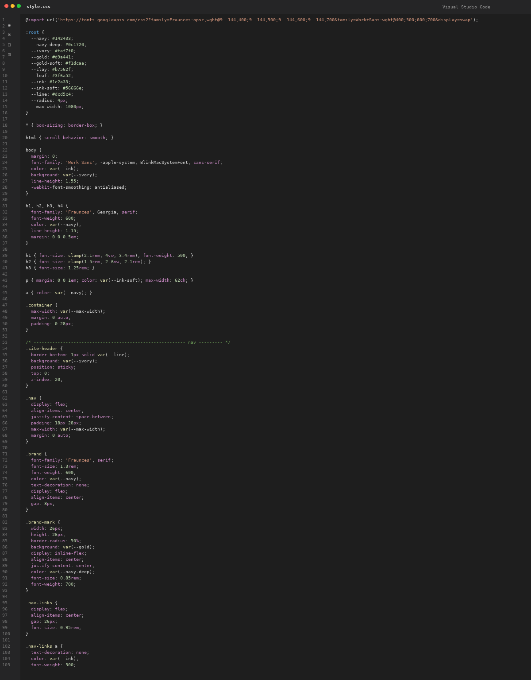
Figure 8: VS Code-style screenshot generated from style.css, opening section.

Activity 4.1: Responsive Layout and Planner Cards
The stylesheet uses reusable buttons, hero sections, planner cards, and form wrappers. Grid-based layout allows the same visual components to be reused across pages.
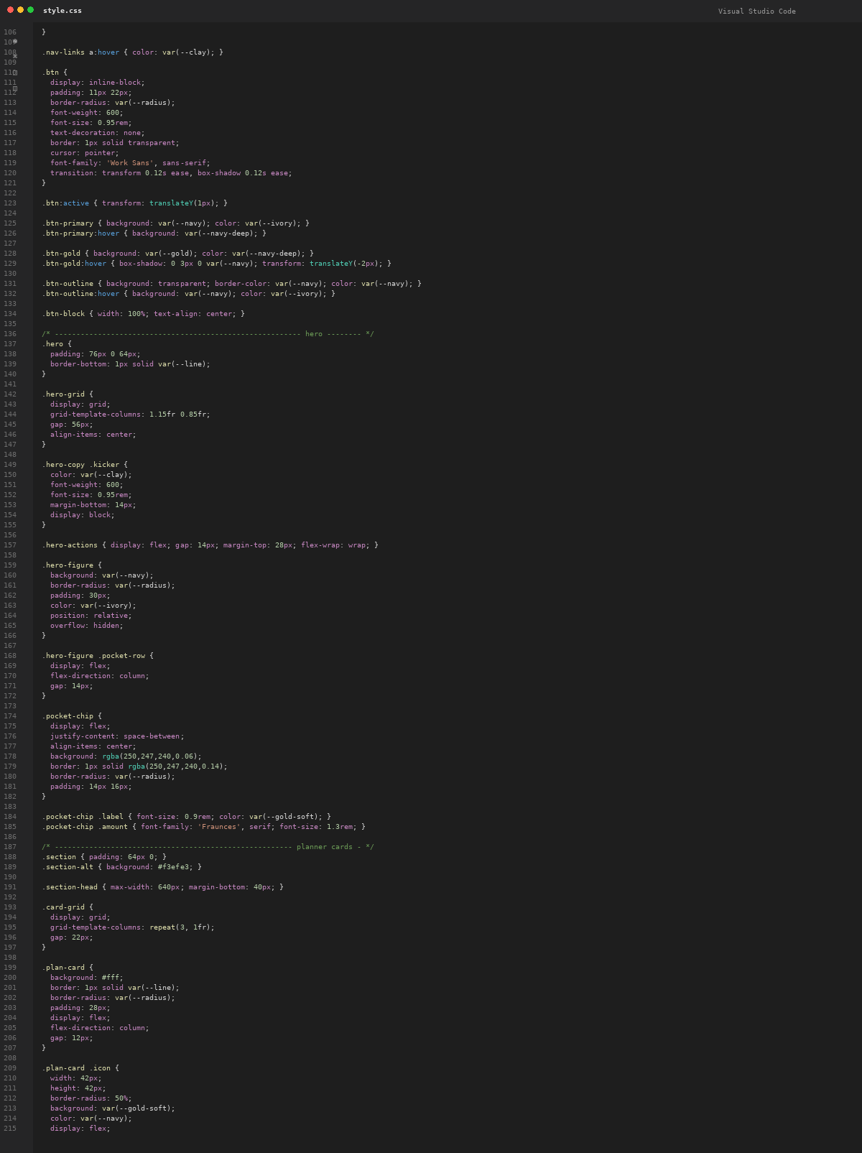
Figure 9: VS Code-style screenshot of buttons, hero and planner-card styles.

Activity 4.2: Results Presentation and Dashboard
The stylesheet defines result summaries, result items, tips, dashboard statistics, history tables, and category pills. These classes support the structured recommendation and history views described in the README.
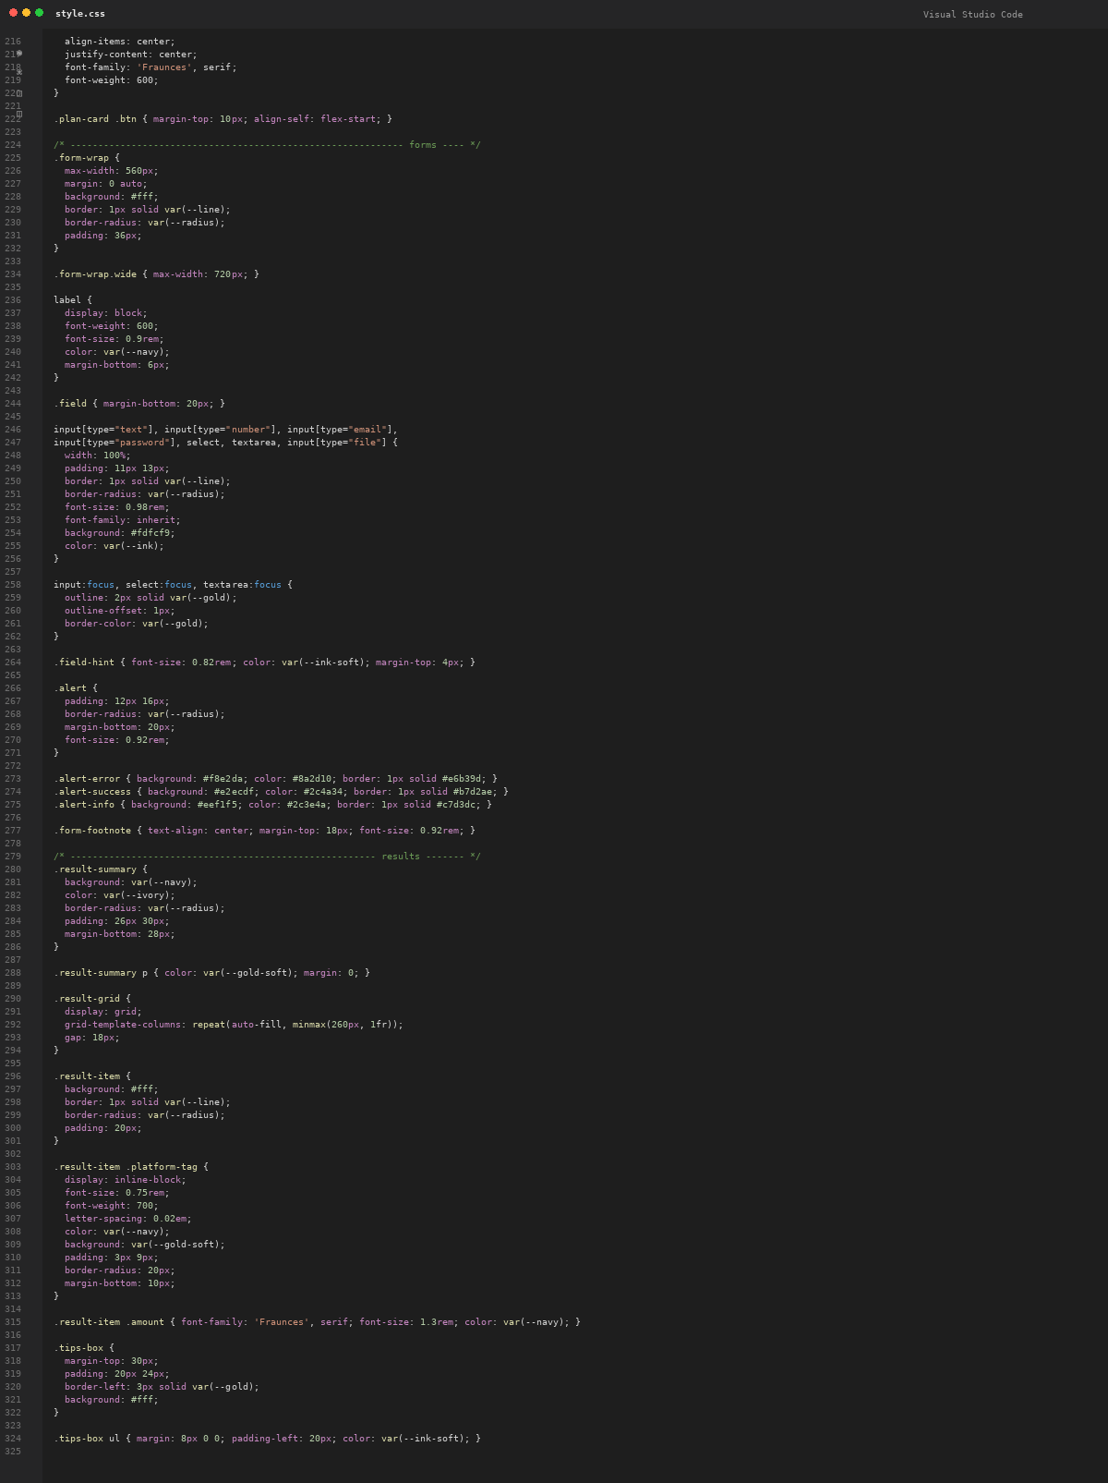
Figure 10: VS Code-style screenshot of forms, results and dashboard styling.

Activity 4.2: Responsive Behavior, History and Footer
The final stylesheet section defines testimonials, footer links, image preview styling, utility classes, and the 860px responsive breakpoint that collapses multi-column layouts.
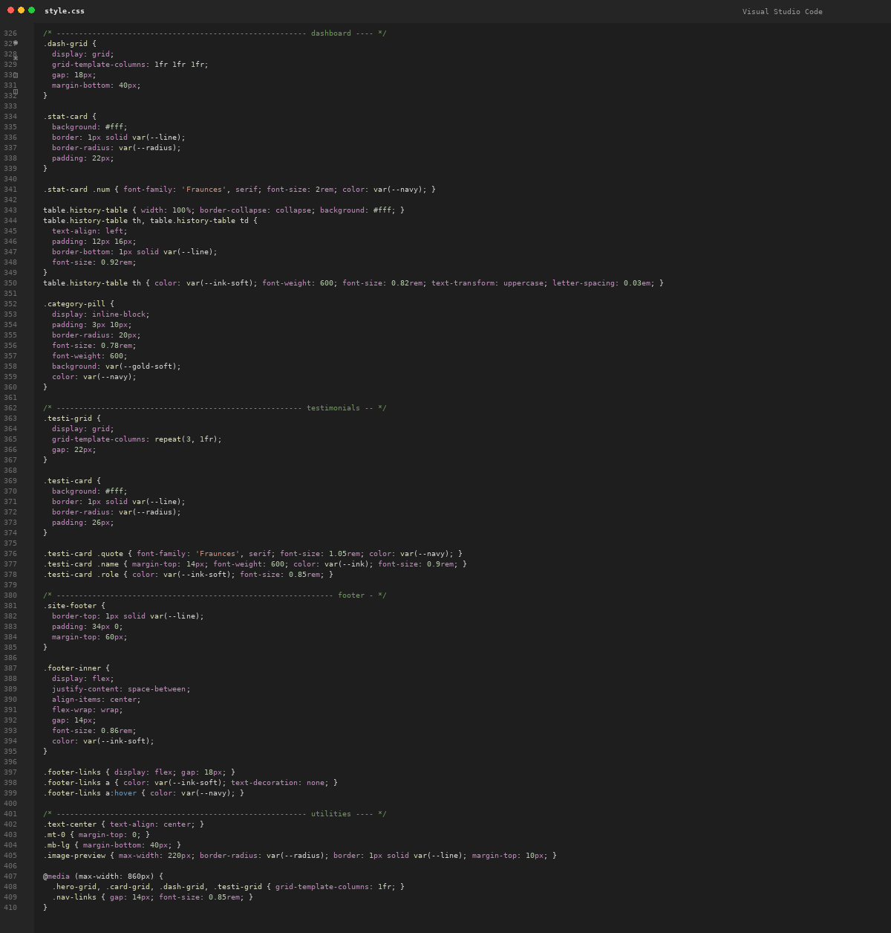
Figure 11: VS Code-style screenshot of history, testimonials, footer and responsive rules.

Milestone 5: Deployment
The project is intended to run locally through Uvicorn. The README documents the development command, browser URL, OAuth2 token endpoint, and interactive FastAPI documentation.
Activity 5.1: Local Deployment
1. Create and activate the virtual environment.
2. Install pinned dependencies.
3. Configure .env.
4. Run uvicorn main:app --reload or python main.py.
5. Open http://127.0.0.1:8000.
Activity 5.2: Local Testing and Verification
• Register and log in.
• Open the dashboard and each planner.
• Submit planner forms and inspect generated results.
• Verify history is recorded per user.
• Check /health and /docs.

Activity 5.3: AI Response and Fallback Verification
The README documents a resilient AI flow. When Gemini is reachable, the planner uses the Gemini recommendation functions. When the API is unreachable or no key is configured, the project uses deterministic local fallback estimates. Jewelry can additionally pass uploaded image bytes into its recommendation function.
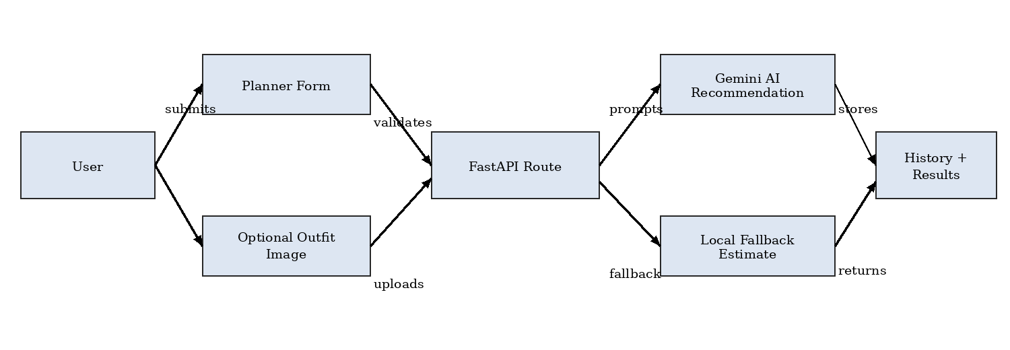
Figure 12: Data-flow diagram for normal Gemini processing and local fallback.

Exploring the Website’s Web Pages:
Home / Generator Page:
The / route renders index.html. The README identifies registration, login, dashboard, planner pages, recommendations, history, and testimonials as the application experience. Because the template files were not uploaded, this report does not fabricate live UI screenshots.

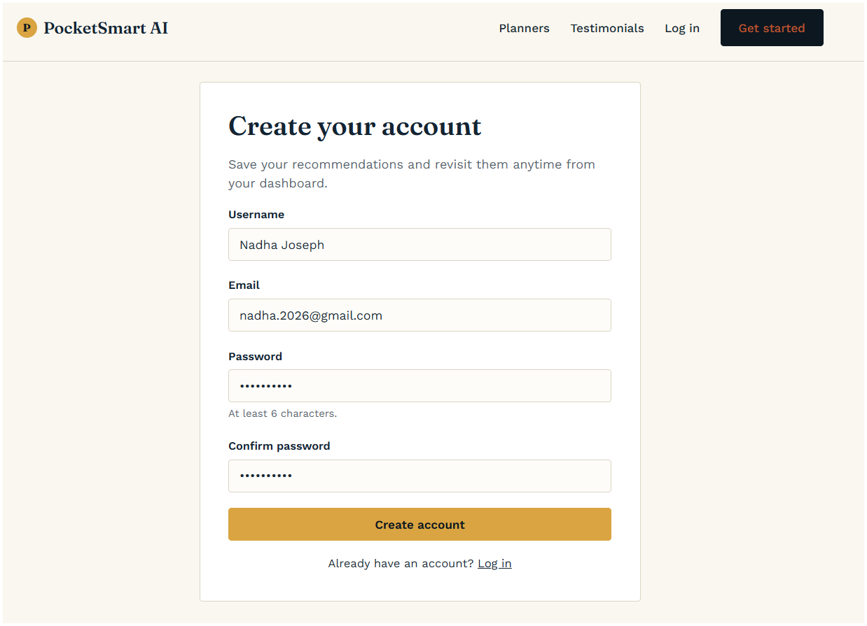

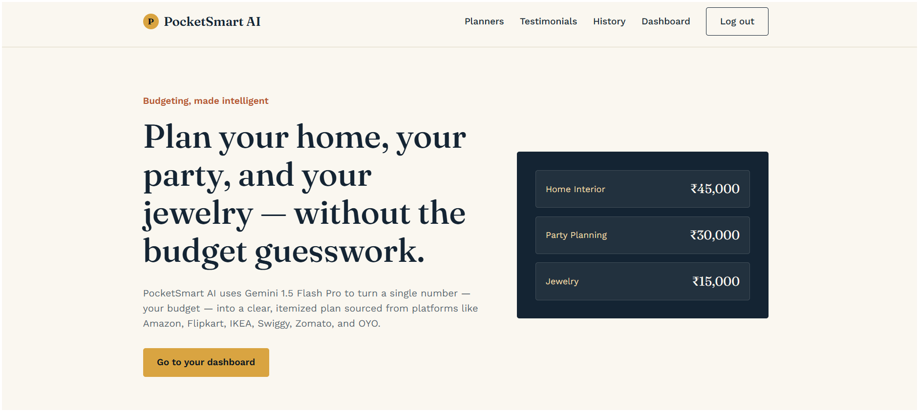

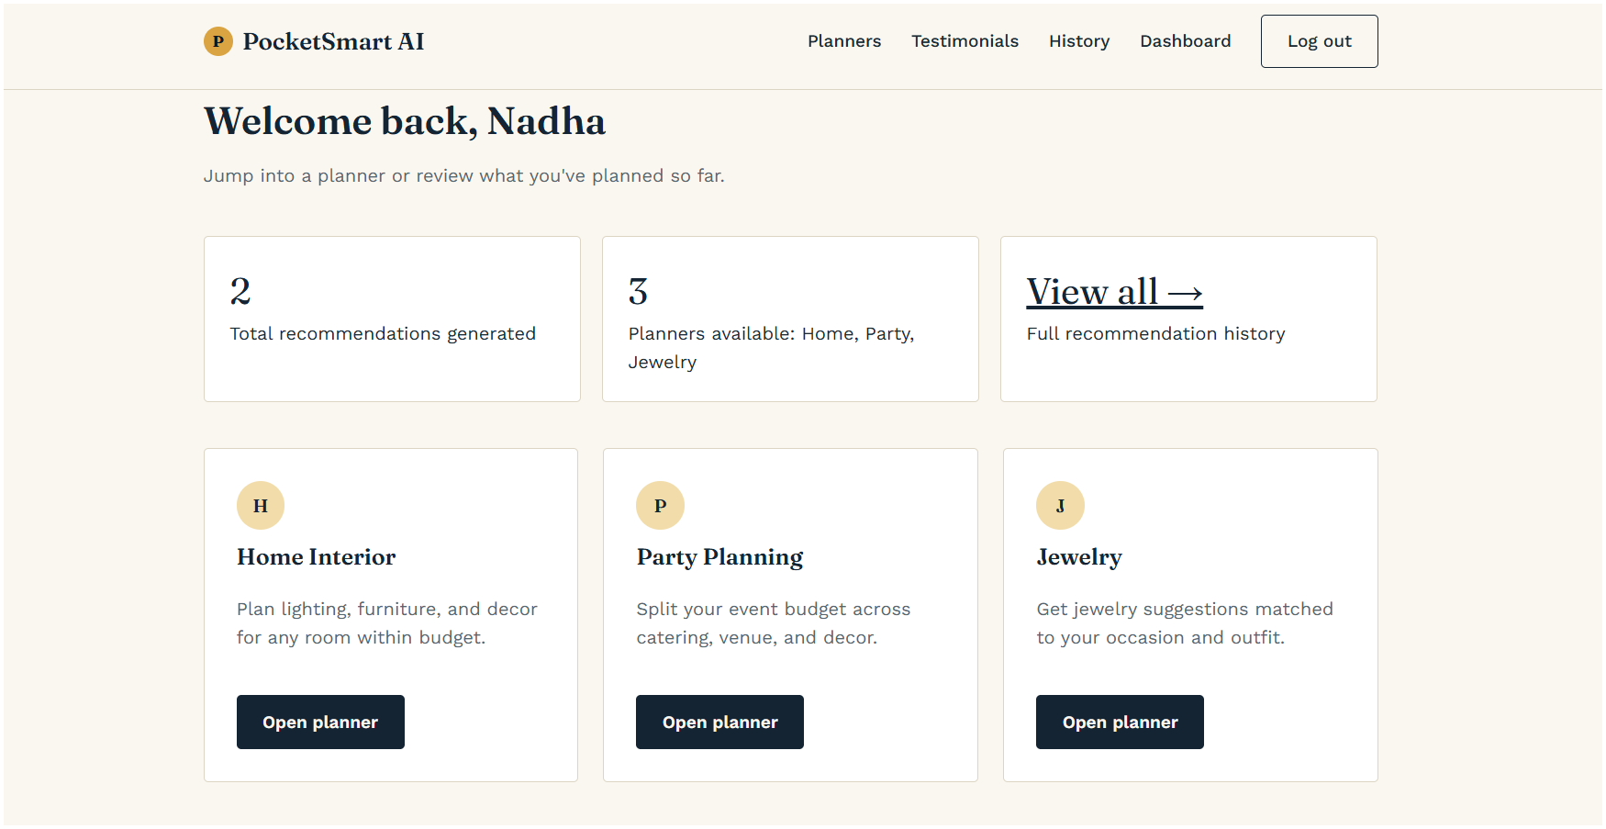

Input Section:
Home accepts budget, room types, items and style. Party accepts budget, guest count, event type, venue preference and location. Jewelry accepts budget, occasion, style and an optional outfit image.

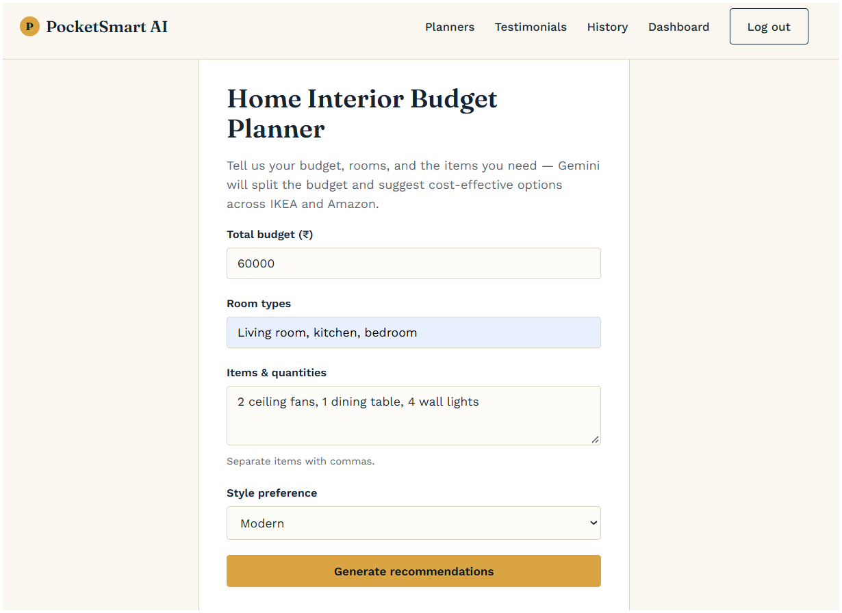

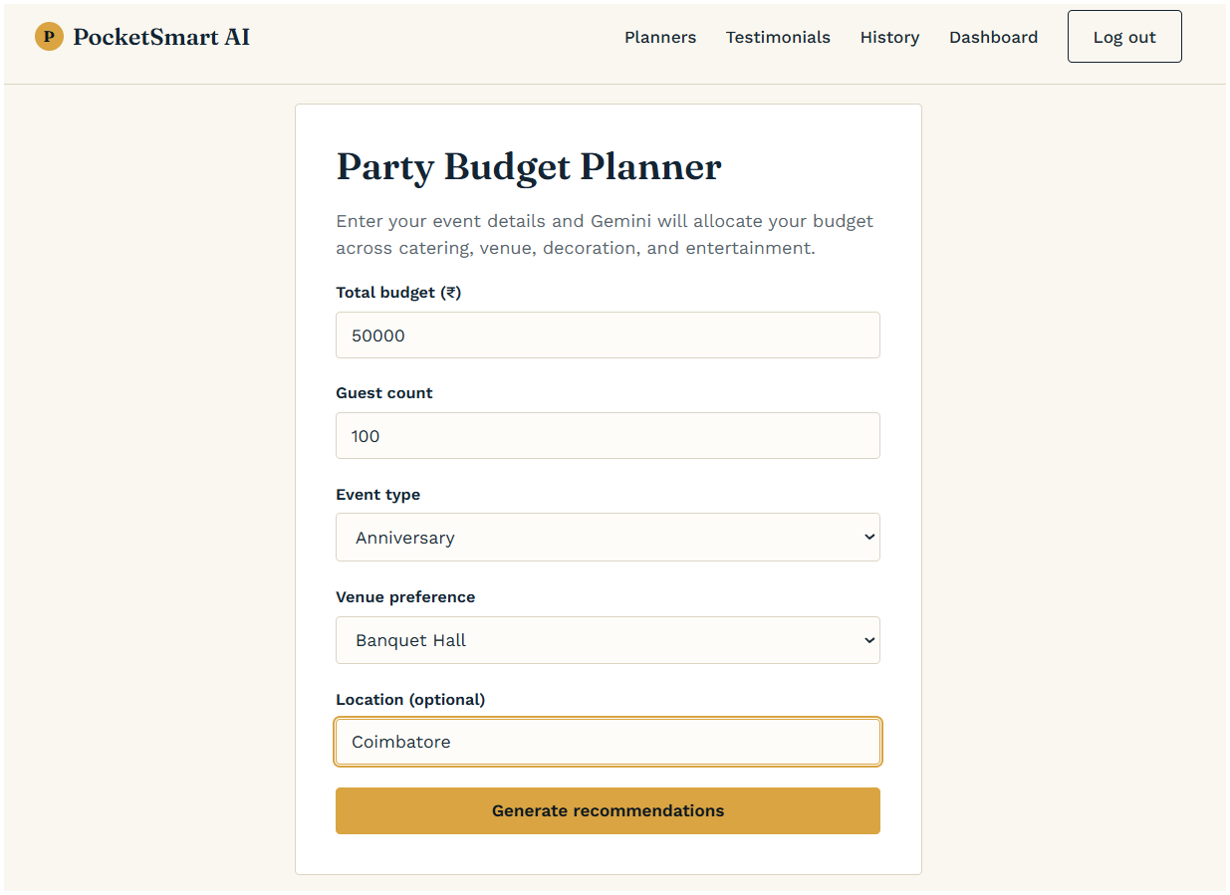

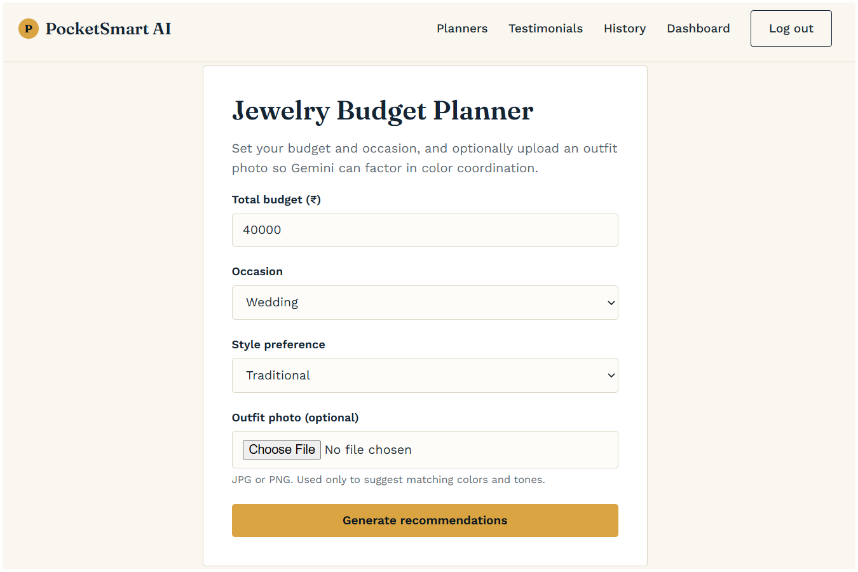

Results Section:
Generation routes render recommendations.html with user, category, input_data and result. The generated recommendation is also written to history for later retrieval. The /recommendations-details/{entry_id} endpoint returns a matching record as JSON.

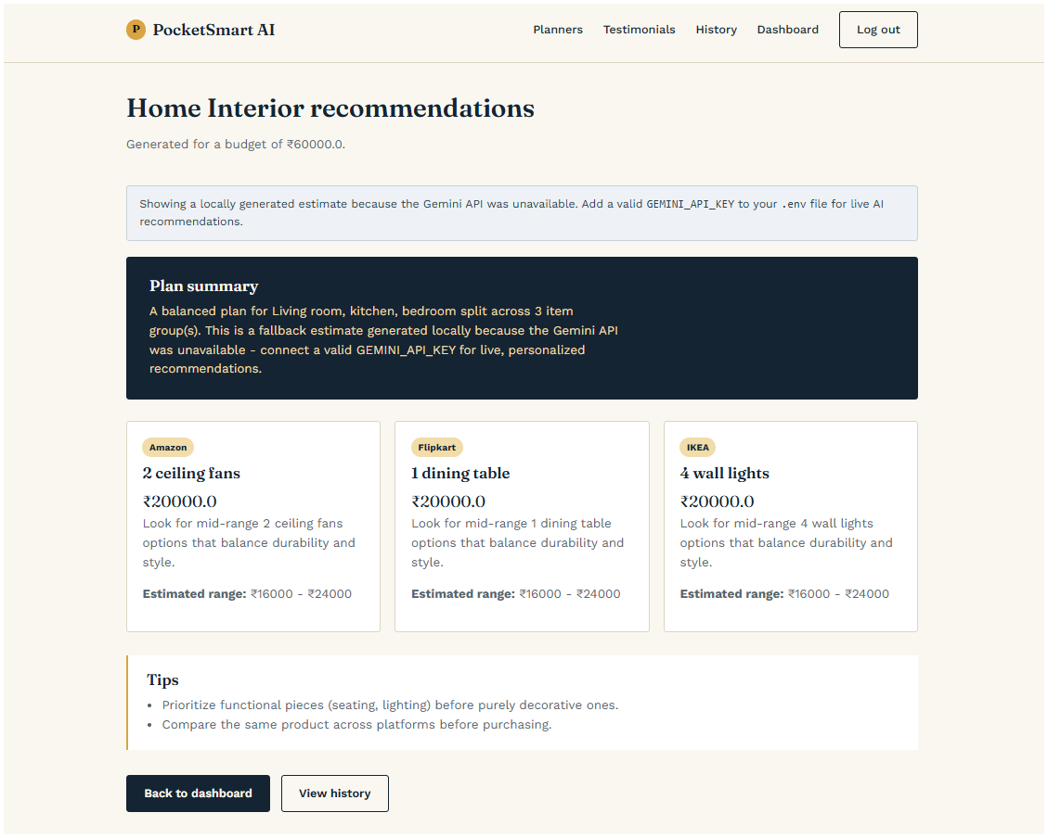

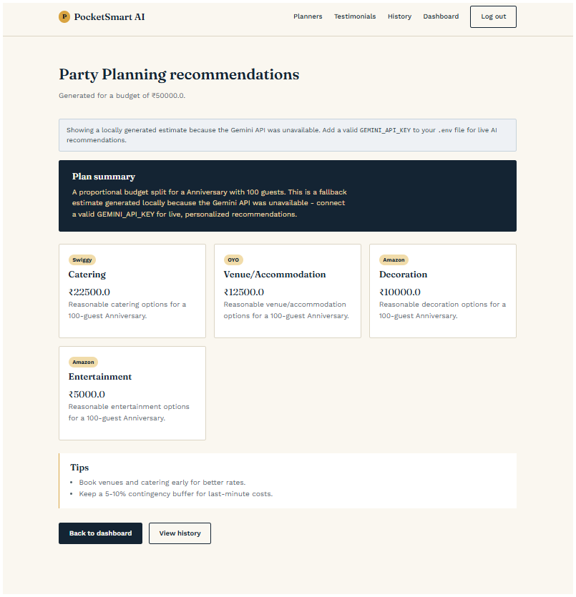
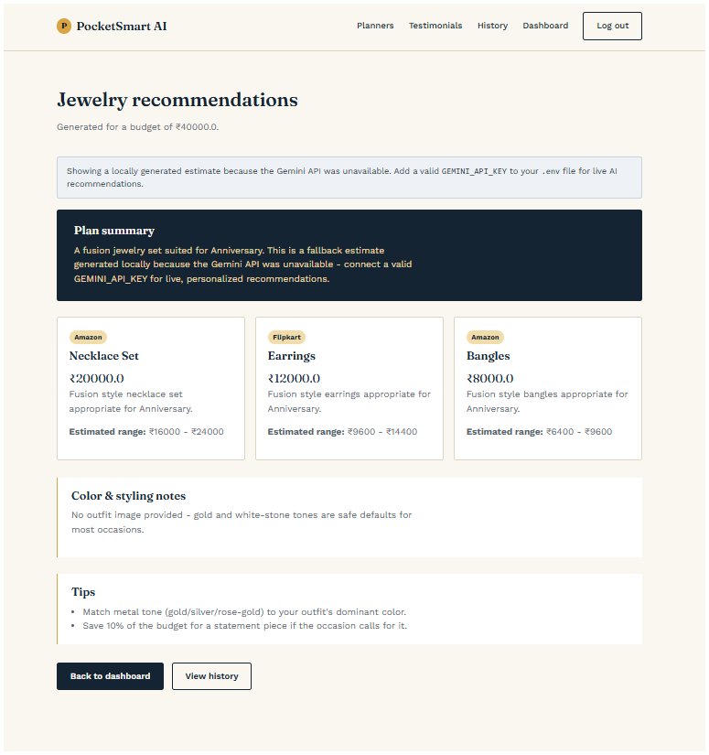

History Section:
The History section stores the user's previously generated recommendations from the Home, Party, and Jewelry planners.
Users can review their past inputs and AI-generated recommendations for easy reference and comparison.
The history is maintained separately for each authenticated user and retrieved from the application's JSON-based database.
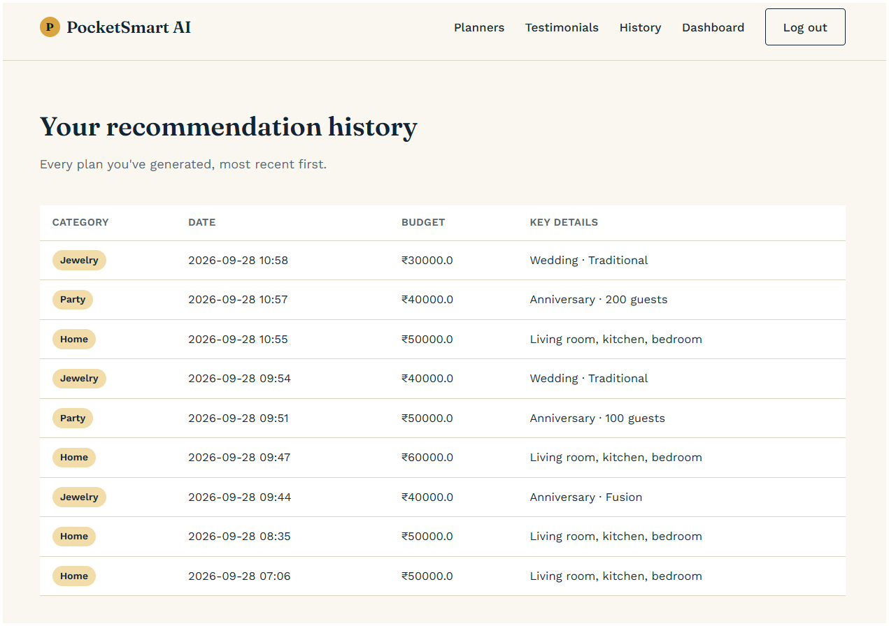

Conclusion:
PocketSmart AI demonstrates a practical GenAI application that combines web development, authentication, persistent user history, Gemini integration, and multimodal input. Its modular architecture makes the three planners share infrastructure while retaining domain-specific planning logic.
Future enhancements include migrating the JSON-file store to a production database, restricting CORS, adding automated tests, improving structured AI validation, adding more planning domains, and introducing production-grade deployment and secret management.

